

**DATABASE DESIGN FOR HAYAT HOSPITAL**

By

**Abdallah Sukkar**

(abdallah.sukkar@lau.edu)

**Tamer Kobba**

(tamer.kobba@lau.edu)

A REPORT

Submitted to Dr. Hussein Bakri in partial fulfillment of the requirements of phase 3 of the database project for the course CSC/BIF 375 – Database Management System

December 2022

***Table of Contents***

***Introduction……………………………………………………………………………………...3***

***Tools used to draw the ER…………………………………………………………………4***

***System Description & Requirements………………………………………………….4***

***Legend of ER Diagram symbols………………………………………………………….5***

***Complete ER Diagram for Hayat Hospital database…………………………..7***

***Entity types & their Attributes…………………………………………………………..8***

***Relationships and their explanations……………………………………………….21***

***Er to relational Mapping………………………………………………………………….35***

***Final Display………………………………………………………………………………….46***

***Tables in SQL……………………………………………………………………………………50***

***Table States……………………………………………………………………………………….56***

***Conclusion……………………………………………………………………………………….58***

Introduction:

A hospital is a facility where patients may get medical and nursing treatment, as well as medical supplies. Generally, it features an emergency room to deal with victims of fires and accidents, as well as medical crises. This is the most prevalent form of a hospital. Since good health is crucial to a happy society, hospitals need to provide efficient services because they are important institutions. As a result, a system that enables hospital management to make effective and efficient decisions is required. In the modern, it has become the standard for all institutions to adopt a database system for handling information and hospitals are no exception with the excess of data they receive on patients, workers, medicinal supplies and so much more it would benefit them greatly. It would ease doctors’ access to a patient’s information leading to less time wasted using the old-school approach of collecting them on physical files which would save time which is paramount in this field especially as human lives are at stake. This report will offer up a possible database for Hayat hospital’s main database design using an Entity-Relationship diagram. In the System description and requirements section, we offer a description of the requirements of the entities and relationships that are going to be present in our ER. In the Entities section, we will describe every single entity and the reasoning behind their presence in addition to their accompanying attributes. In addition, the Relationship section similarly to the entities section offer explanations of the present relationships themselves and the reasoning behind their presence

***Tools used to draw the ER:***

We used the Dia program to draw the ER diagram

**IV- System Description & Requirements:**

* A hospital branch is identified by its city, street and postal code. A branch state should also be mentioned.
* A department is identified by a name and a description. Each hospital has at least one department.
* Each Lab has a unique name and location which can be subdivided into a room and a floor. A hospital can contain many labs.
* The equipment has a unique id number, and its type should be recorded. Each equipment is in a lab which is in a department. A department should have at least one piece of equipment, and the same goes for a lab.
* Each employee is identified by an SSN, gender, birth date, type (janitor, staff, nurse, etc.), and a name (first and last name). An employee can supervise another employee and each employee should supervised by a supervisor which is an employee. Furthermore, an employee works in a department and can manage one department, and each department should have at least one worker and only one manager.
* An employee can be a doctor. A doctor is identified by an SSN, gender, specialization, a name (First and Last name), and an office location that contains a floor and a room.
* Each hospital patient has a name (First and Last name), a birth date, and could have multiple cases or diseases. And the patient’s age should be recorded as well.
* A doctor can treat multiple patients, and each patient can be treated by many doctors but should be treated by at least one.
* A patient can have multiple appointments and each appointment should be identified by a number, a date, a location in the hospital that contains a floor and a room and can have multiple reasons.
* A patient can be classified by a resident in the hospital. A resident in the hospital is identified by his date of entrance and a location in the hospital which contains a floor and a room. His residence period should be recorded.
* Each patient has at least one payment that he should pay to the hospital, a payment is identified by its amount, a deadline and a payment ID that uniquely identify it.
* Each patient has a medical record that includes his drugs, surgeries and diagnoses. No patient can have the same drug, surgery or diagnosis repeated multiple times.

**Legend:**

|  |  |
| --- | --- |
| Name | Symbol |
| Entity |  |
| Weak Entity |  |
| Attribute |  |
| Primary Key |  |
| Multivalued Key |  |
| Derived Attribute |  |
| Relationship |  |
| Partial Participation |  |
| Total Participation |  |

***Complete ER Diagram for Hayat Hospital database***

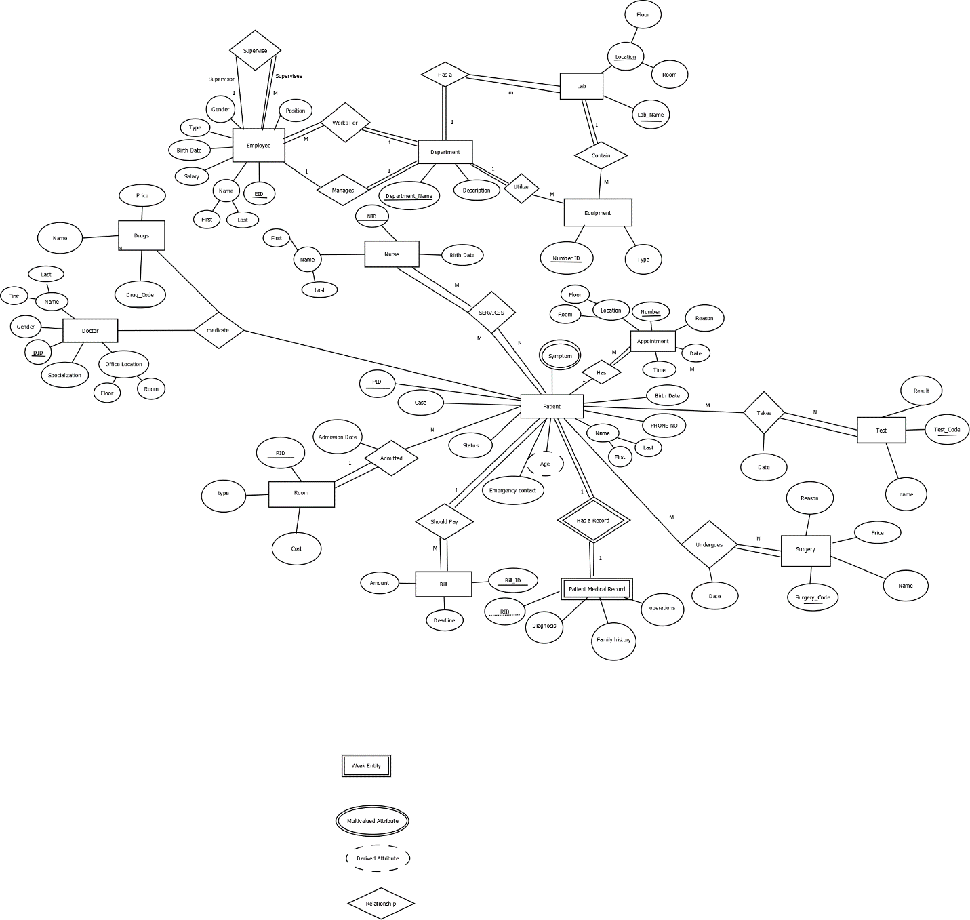

Entities

1. Employee:

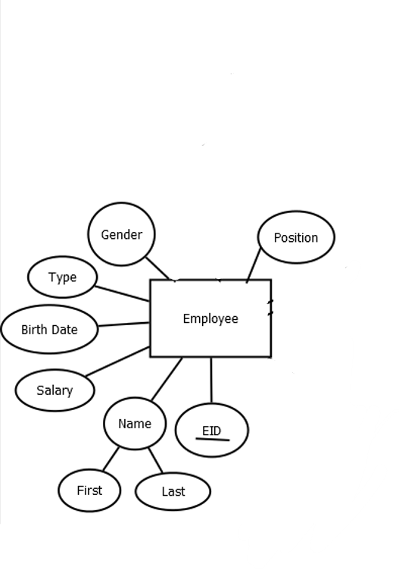

Employee is part of the staff of the hospital in which each individual is responsible for a specific role for the hospital to run optimally. It could be nurses, doctors, accountants, department managers, or other employees which comprise the unskilled workforce of the hospital that are responsible for menial tasks such as janitorial work or cafeteria servers. The Employee’s primary key is its EID, for it is the unique eight­-digit number for the employee that can be used for identification. In addition, other attributes are present too to give information about the Employee:

● **Salary:** Stores the salary of the Employee.

● **Gender**: The gender of the person: male, female or other.

● **Address:** Stores the address of the employee

● **Phone Number:** Stores the phone number of the Employee.

● **Birth Date:** Stores the date of birth of the employee

● **Name:** The first and last name of the employee

● **Position**: Stores the specific occupation of each employee at the hospital

1. Department:

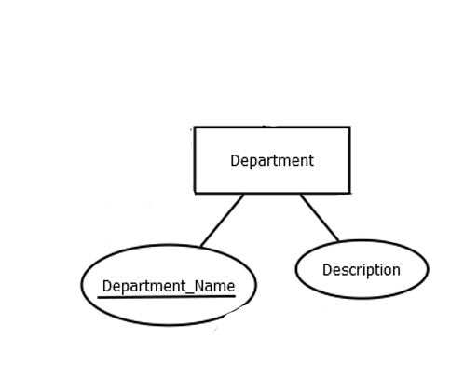

A hospital's departments A hospital is made up of various departments, including clinical departments, nursing departments, support departments, technical departments, and administrative departments. In a hospital, each department serves a particular purpose and the various needs of the hospital. The Department’s primary key is its Department_Name, for it is the unique name of each department that can be used for identification of each one. Its attributes include:

● Description: Description of the department.

1. Doctor:

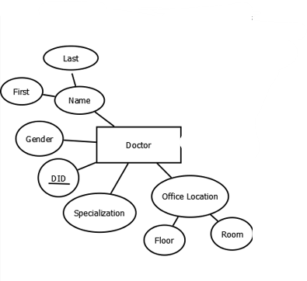

A doctor is a licensed physician who is a graduate of an accredited medical school. Primary Care M.D.s deliver basic diagnostic and preventive medical care. Doctor possesses one key attribute its DID, for it is the unique Five­-digit number of the Doctor that can be used for identification. Moreover, Doctor has more attributes:

● **Name:** The first and last name of the employee

● **Gender**: The gender of the person: male, female or other.

● **Specialization:** doctors usually work primarily in their specialized segment of medicine.

● **Office location:** The location of the office where the doctor operates

4. Patient:

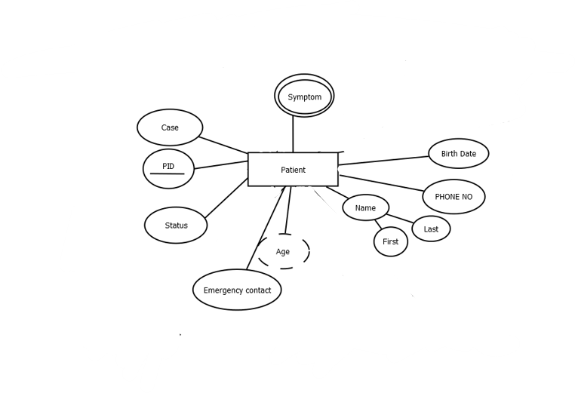

A Patient’s entity exists to store information about the patient being treated in the hospital. A patient is a person who is ill or is undergoing treatment to cure his disease. Doctor possesses a primary key its PID, for it is the unique Six -digit number of the Patient r that can be used for identification

● **Name:** The first and last name of the patient

● **Birth Date:** Stores the date of birth of the patient.

● **Case:** Stores the diagnosed condition that the patient is suffering from.

● **Status:** Whether the patient is an in-patient or not

● **Phone_NO:** Stores the phone number that the hospital will use to contact the patient

● **Emergency:** The contact information of the individual the hospital should contact if the patient is admitted to the hospital

One multivalued attribute exists which is:

● **Symptoms**: The symptoms that the patient is suffering from. They could suffer from multiple Symptoms

As for the derived attribute:

● **Age:** is derived from the birth date of the patient.

6. Lab:

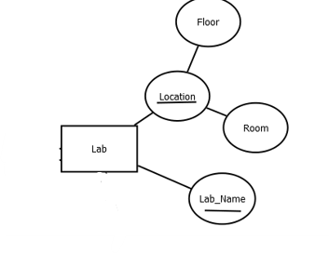

The lab can be identified by Lab_Name and Location which are considered the primary keys for this entity. With lab is the location where medical tests are conducted either for medical research or to test out samples from the patients to get an accurate diagnosis of the patient’s condition.

7. Equipment:

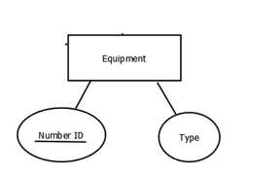

The Equipment entity’s purpose is to store information about equipment being utilized in hospital rooms and labs. Equipment can be identified by a number ID which is a unique 3-digit number that is the primary key of this entity. The other attribute is:

● **Type:** Medical equipment is intended to help in the diagnosis, monitoring, and treatment of patients in a variety of healthcare departments

8. Bill:

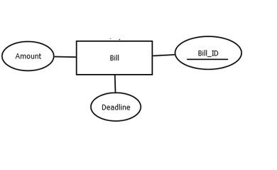

Transactions are made here; a copy of every payment is stored and the fee/payment should be made by patients before the deadline. The Bill entity can be identified by a unique six-digit number Bill_ID which is the primary key of this entity. Bill consists of 2 more entities which are:

●**Amount:** which represents the remaining money that has not been yet settled.

● **Deadline:** maximum amount allowed time for when payment should be made before consequences arise for not paying

9. Appointment:

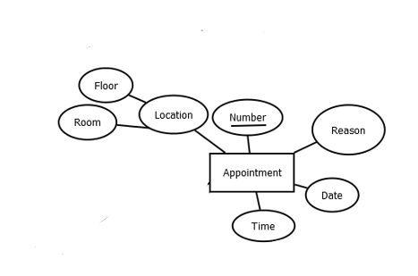

The Appointment entity schedules a meeting between a patient and his physician. The specific appointment can be identified through the unique appointment Number which is five-digits that is considered the primary key of this entity. Other attributes are:

●**Location:** At the floor and room will the appointment be conducted.

●**Date:** Stores the date of when the appointment will be conducted

●**Time:** Stores the length of the appointment.

●**Reason:** Why the patient is booking an appointment

10. Patient Medical Record:

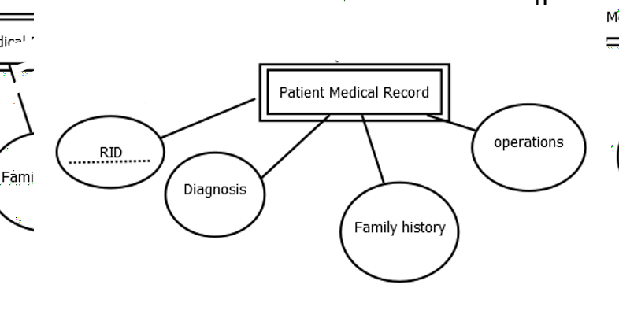

Patient Medical Record is a weak entity that each patient possesses in order to make sure patients receive great quality care, as it provides all healthcare providers insight into everything about you. From your medical history to social information, they get a better picture of what the best route of treatment is for the patient. RID is considered the partial key of this entity, it is a unique four-digit number that is used to identify the medical record of each patient. Its attributes include:

●**Drugs:** Previous medications the patient was prescribed by previous doctors

●**Surgery:** surgeries the patient has gone through

●**Diagnosis:** Previous medical conditions that patients were diagnosed with

●**Family history:** details about health problems your blood relatives have had during their lifetimes.

11. Room:

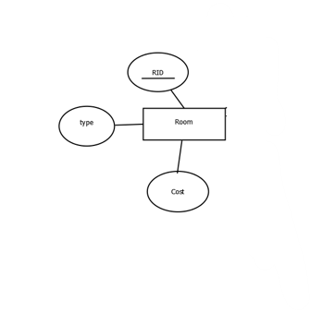

The Room entity is where in-patients are kept and monitored by doctors and nurses until they are found fit enough to return back home. The specific Room can be identified through the unique RID (Room ID) four-digit number which is considered the primary key of this entity. Other attributes are:

●**Cost:** The amount of money has to pay for being accommodated in the room

●**Type:** The amount of patients the room can accommodate.

13. Nurse:

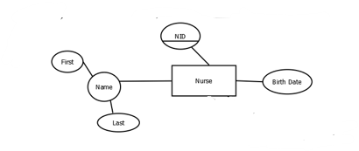

A **Nurse** is responsible for caring for patients, sick or well, assessing their health status, and assisting them in the performance of those activities they would perform unaided if they had the necessary strength, will, or knowledge to do this in such a way as to help them gain full of partial independence as rapidly as possible. Nurse possesses one primary key its NID, for it is the unique four­-digit number of the Nurse that can be used for identification. Moreover, Nurse has more attributes:

● **Name:** The first and last name of the Nurse

● **Birth Date:** Stores the date of birth of the employee

14. Drugs:

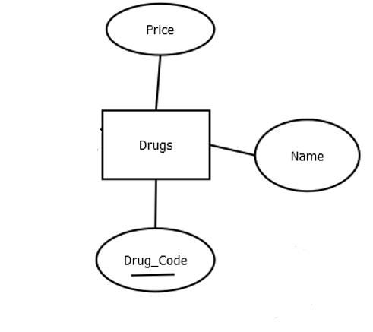

a drug used to diagnose, cure, treat or prevent disease. It is prescribed to a patient by a doctor. The Drugs entity has one primary key its Drug_Code which is the unique three-character string of each drug that can be used for identification. Drugs have more attributes:

● **Name:** The designated name of the drug

● **Price:** the price of the prescribed drug

15.Test:

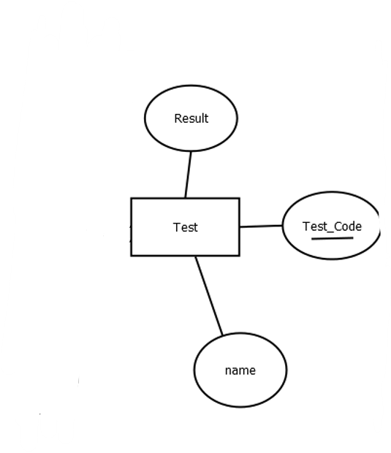

A Test is a medical technique that is used to identify, diagnose, monitor illnesses, disease processes, susceptibility, or to select a treatment plan. The Test entity has a key attribute Test Code which is a unique three-digit number used to identify each test performed on every patient. Test also has other attributes:

● **Name:** The designated name of the test performed

● **Result:** The results of the medical test

16. Surgery:

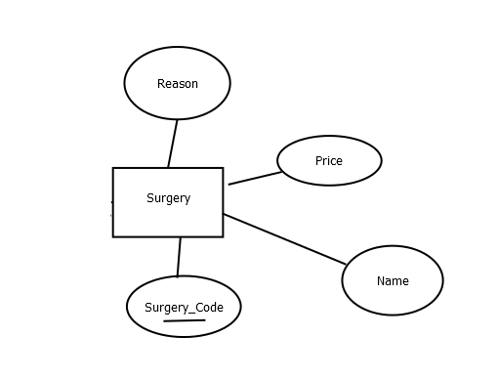

**Surgery is an invasive procedure**. This means that surgery involves cutting into the body in order to treat a condition. Surgery is typically used to treat conditions that cannot be treated with less invasive methods, such as medication or therapy. The **Surgery’s** primary key is its Surgery Code, for it is the unique three-character string for each surgery performed that can be used for identification. Surgery also has other attributes:

● **Name:** The designated name of the surgery performed

● **Reason:** why the surgery had to be performed on the patient

● **Price:** The price of the surgery to be performed

Relationships:

1. Works For:

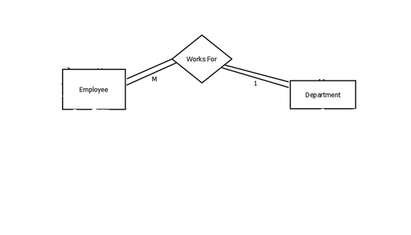

all employees must be allocated to a certain department, a "Works For" relationship must be established between the Employee entity and the Department entity. Participation is total on both sides since each employee must belong to exactly one department, and each department must have at least one to function.

An Employee can only “Work For” one Department, but a Department can have one or more Employees.

1. Manages:

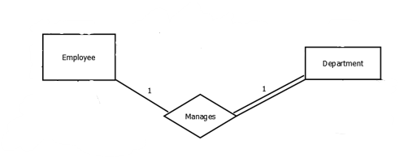

Each Department needs an employee to manage its affairs. Thus, a” Manages” relationship has to be created between the Employee entity and the Department entity. The participation is partial on the Employee side and total on the Department side because every department has an employee to manage it, but not every employee manages a department.

An Employee “Manages” one Department and each Department has one manager.

1. Should Pay:

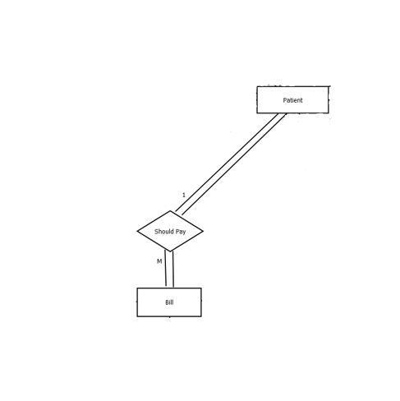

Each Patient must pay medical fees for the treatment they received. Thus, a” Should Pay” relationship has to be created between the Patient and the Payment. The participation is total on both sides since many patients have to pay their medical bills, while each medical bill is specified to each patient depending on their treatment.

A Patient” should pay” one or more than one bill whereas the payment can be paid only by one Patient

1. Has a Record:

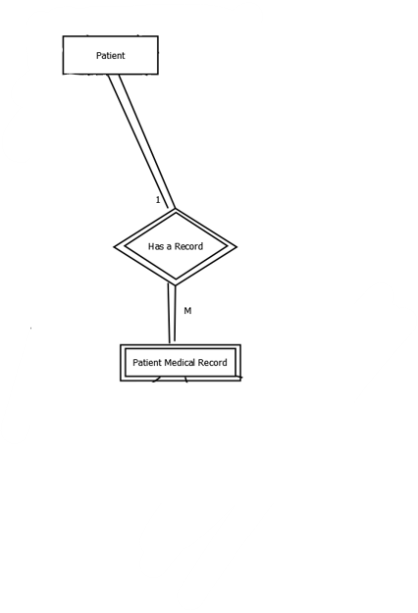

Each patient has a medical record for him to receive better treatment. So, a “Has a Record" relationship has to be created between the Patient entity and the Patient Medical Record weak entity. Participation is full on both sides since all patients must have a medical record.

A Patient “Has a Record” one or more depending on how much doctors will know about what is affecting him while multiple medical records can be associated to one Patient.

1. Has:

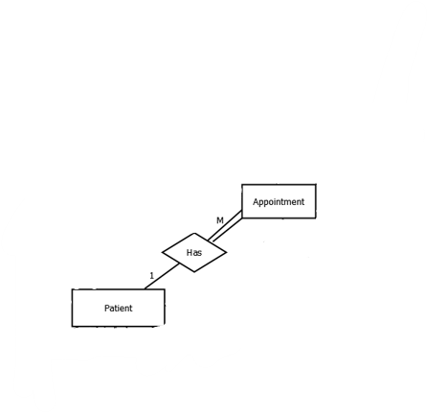

Each patient usually has to take an appointment at the hospital to be checked by doctors, so a” Has” relation has to be created between Patient entity and the Appointment entity. The participation is partial on patient side and total on the appointment side since each appointment has to be taken by a patient but not every Patient has to take an appointment to be administered to the hospital

A patient “Has” one or many appointments while each appointment is only for one patient.

1. Supervise:

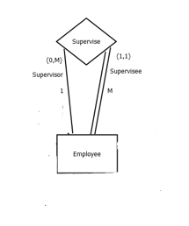

An employee requires supervision by a supervisor who is also an employee while the employee being supervised is called a supervisee. So, a” Supervise” relationship has to be created between Employee entity and itself. The participation is partial on the supervisor side and total on the supervisee side many employees are considered supervisee and require supervision, but not all employees can be a supervisor.

A Employee” Supervise” one or more Employees but Employees can only be “supervised” by one supervisor.

1. Has a:

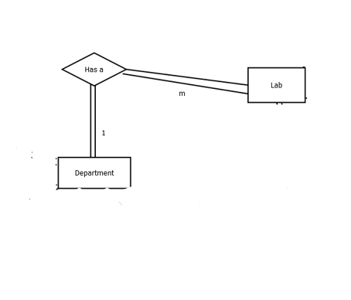

Each department contains many Labs. So, a “Has a” relationship has to be created between the Lab entity and the Department entity. The participation on both sides is total since all departments have labs and every lab belongs to a department.

A department” has a” many labs whereas a lab may be found in one department only

1. Contain:

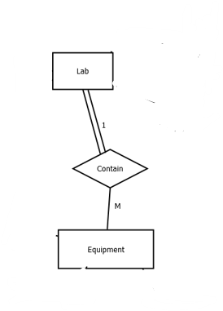

Each lab contains many equipment. So, a “Contain” relationship has to be created between the Lab entity and the Equipment entity. The participation on Lab total since all Labs have equipment while participation is partial on equipment since not all equipment will be in labs

A Lab” contain” many equipment whereas certain equipment may be found in one lab only

1. Utilize:

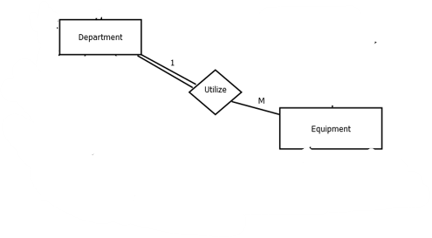

Each Department utilize many equipment. So, a “Utilize” relationship has to be created between the Department entity and the Equipment entity. The participation on Department total since all Department use equipment while participation is partial on equipment since not all equipment will be used by a department

A Department” Utilize” many equipment whereas certain equipment may be used by a certain department

1. Services:

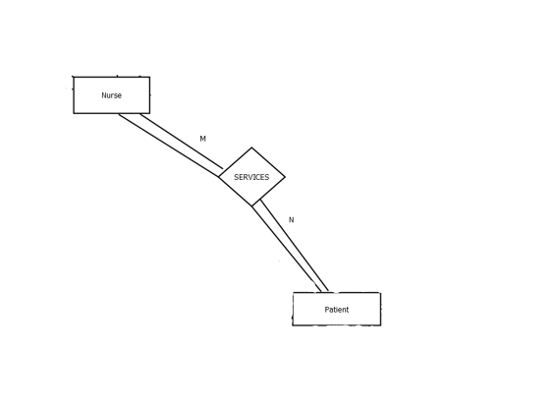

All nurses are responsible to service their patient during their stay at the hospital. Thus, a “SERVICES” relationship has to be created between the Nurse entity and the patient entity. The participation is total on the patient side and partial on the Nurse side since many patients have to be Serviced by many Nurses, while all Nurses need to service the patients under their care.

A Nurse “SERVICES” one or more Patients while a Patient can be treated by multiple Nurses.

1. Admitted:

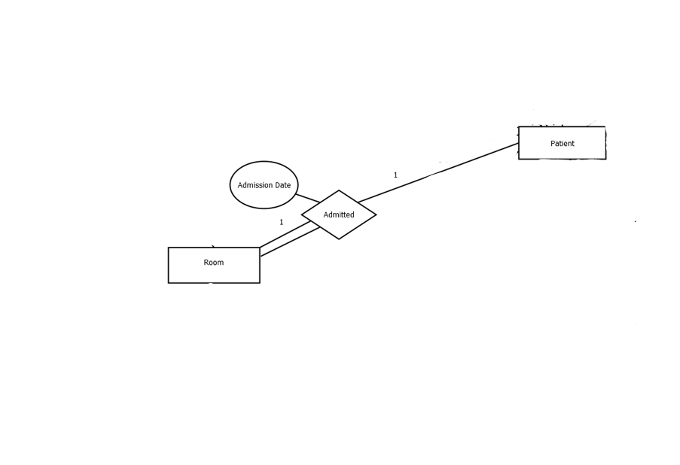

Each Patient depending on the severity of their condition may be admitted to the hospital. Thus, an “Admitted” relationship has to be created between the Patient and Room Entity. The participation is partial on the patient side because not all patients will be admitted to a room, but its total participation on the Room side because all rooms must have a patient present in them.

Each Patient is” Admitted” to one Room and each Room can contain one or more Patients. The relationship “Admitted” has one attribute:

●**Admission Date**: The date on which the patient is admitted into the room

Undergoes:

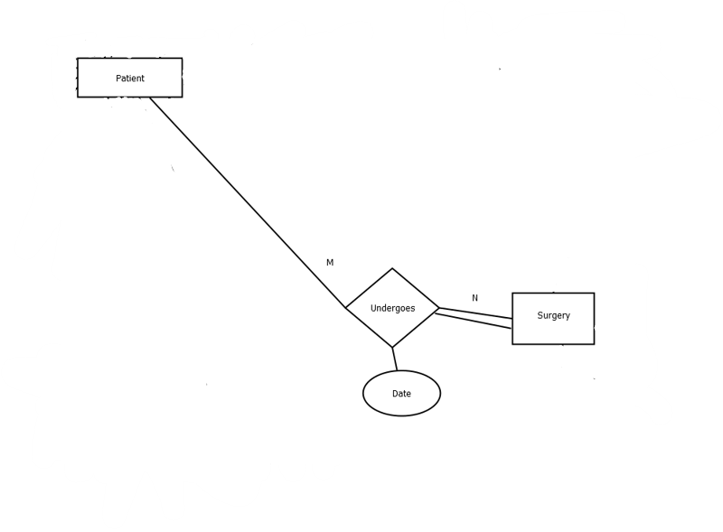

A patient may need to undergo surgery, so an “Undergoes” relationship is needed between the Patient entity and the Surgery entity. The participation is partial on the patient side because not all patients will need to undergo surgery, but its total participation on the Surgery side because all surgeries are done on patients

Each Patient” Undergoes” one or more surgeries and many surgeries may be done on one Patient. The relationship “Undergoes” has one attribute:

●**Date**: The date on which the patient undergoes surgery

1. Takes:

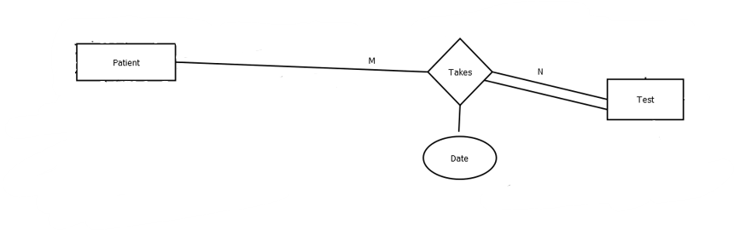

A patient may need to take a medical test, so an “Takes” relationship is needed between the Patient entity and the Test entity. The participation is partial on the patient side because not all patients will need to do a medical test, but its total participation on the Test side because all medical tests are done on patients

Each Patient” Takes” one or more tests and many medical tests may be done on one Patient. The relationship “Undergoes” has one attribute:

●**Date**: The date on which the patient takes the medical test

1. Medicate:

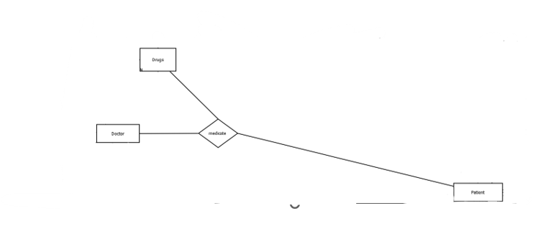

A patient may be administered with drugs to alleviate their sickness by doctors, so a “Medicate” ternary relationship is needed between the Patient entity, the Drugs entity, and the Doctor entity .As doctors administer the drugs to the patient and the patient takes the drugs

***Er to relational Mapping***

**Step 1 – Mapping of Strong Entities:**

**Department**

|  |  |
| --- | --- |
| Department_Name | Description |

Key attributes: Department_Name

**Employee**

|  |  |  |  |  |  |  |  |
| --- | --- | --- | --- | --- | --- | --- | --- |
| EID | First_Name | Last_Name | Salary | Birth_Date | Type | Gender | Position |

key attributes: EID

**Lab**

|  |  |  |
| --- | --- | --- |
| Lab_Name | Floor | Room |

Key attributes: Lab_Name, (Floor, Room)combination

**Equipment**

|  |  |
| --- | --- |
| Number_ID | Type |

key attributes: Number_ID

**Nurse**

|  |  |  |  |
| --- | --- | --- | --- |
| NID | First_Name | Last_Name | Birth_Date |

key attributes: NID

**Doctor**

|  |  |  |  |  |  |  |
| --- | --- | --- | --- | --- | --- | --- |
| DID | Floor | Room | First_Name | Last_Name | Specialization | Gender |

Key attributes: DID, (Floor, Room) combination

**Patient**

|  |  |  |  |  |  |  |  |
| --- | --- | --- | --- | --- | --- | --- | --- |
| PID | Case | Status | First_Name | Last_Name | Birth_Date | Emergency_contact | Phone_NO |

Key attributes: PID

**Test**

|  |  |  |
| --- | --- | --- |
| Test_Code | Name | Result |

key attributes: Test_Code

**Drugs**

|  |  |  |
| --- | --- | --- |
| Drug_Code | Name | Price |

key attributes: Drug_Code

**Surgery**

|  |  |  |  |
| --- | --- | --- | --- |
| Surgery_Code | Name | Price | Reason |

key attributes: Surgery_Code

**Bill**

|  |  |  |
| --- | --- | --- |
| Bill_ID | Amount | Deadline |

key attributes: Bill_ID

**Room**

|  |  |  |  |
| --- | --- | --- | --- |
| RID | Cost | Status | Type |

**Appointment**

|  |  |  |  |  |
| --- | --- | --- | --- | --- |
| Appointment_Number | Floor | Room | Reason | Date |

Key attributes: Appointment_Number,

**Step 2 – Mapping of Weak Entities:**

**Patient Medical Record**

|  |  |  |  |  |
| --- | --- | --- | --- | --- |
| RID  (Foreign key from Patient Medical Record) | Record_PID (Foreign key from Patient) | Diagnosis | Family_History | Operations |

Foreign keys: RID (the partial key of the weak entity Patient Medical Record) – PID(the primary key of Patient).

Primary key: (RID, PID) their combination

**Step3 – Mapping of Binary 1:1 Relationship Types:**

**Manages**

**Department**

|  |  |  |
| --- | --- | --- |
| Department_Name | DEPARTMENT_EID (Foreign key from Employee) | Description |

Primary key: Name

Foreign key: EID

Since it is a binary 1:1 relationship, we have an entity with a partial participation and the second with a total participation, therefore, to reduce nulls it is more convenient to take a foreign key from the entity type that have a partial participation and place it in the relation of the entity type that have a total participation.

**Step 4 – Mapping of Binary 1:M Relationship Types:**

**Admitted**

**Patient**

|  |  |  |  |  |  |  |  |  |  |
| --- | --- | --- | --- | --- | --- | --- | --- | --- | --- |
| PID | Case | Status | First_Name | Last_Name | Birth_Date | Emergency_contact | Phone_NO | Admission  _Date | RID  (Foreign key from Room) |

Primary Key: PID

Foreign Key: Admission_Date,RID

Since it is a binary 1:M relationship, the foreign key come from the 1 side to the Many side.

**Room**

|  |  |  |  |
| --- | --- | --- | --- |
| RID | Status | Cost | Type |

Primary key: RID

**Works_For**

**Employee**

|  |  |  |  |  |  |  |  |  |  |  |
| --- | --- | --- | --- | --- | --- | --- | --- | --- | --- | --- |
| EID | EMPLOYEES_  DEPARTMENT_NAME (Foreign  key from Department) | Position | Gender | Type | Birht_Date | Salary | First_Name | Last_Name | SUPERVISOR_EID | Supervisee_EID |

Primary Key: EID

Foreign Key: Department_Name, SUPERVISOR_EID, Supervisee_EID

Since it is a binary 1:M relationship, the foreign key come from the 1 side to the Many side.

**Contain**

**Equipment**

|  |  |  |  |
| --- | --- | --- | --- |
| Number_ID | EQUIPMENTS_DEPARTMENT_NAME (foreign key from Department) | Type | EQUIPMENTS_LAB_NAME(foreign key from lab) |

Primary Key: Number_ID

Foreign Key: EQUIPMENTS_DEPARTMENT_NAME, EQUIPMENTS_LAB_NAME

Since it is a binary 1:M relationship, the foreign key come from the 1 side to the Many side.

**Utilize**

**Equipment**

|  |  |  |  |
| --- | --- | --- | --- |
| Number_ID | EQUIPMENTS_DEPARTMENT_NAME (foreign key from Department) | Type | EQUIPMENTS_LAB_NAME(foreign key from lab) |

Primary Key: Number_ID

Foreign Key: EQUIPMENTS_DEPARTMENT_NAME, EQUIPMENTS_LAB_NAME

Since it is a binary 1:M relationship, the foreign key come from the 1 side to the Many side.

**Has**

**Appointment**

|  |  |  |  |  |  |
| --- | --- | --- | --- | --- | --- |
| Appointment_Number | PID(foreign key form Patient) | Floor | Room | Reason | Date |

Primary Key: Appointment_Number

Foreign Key: PID

Since it is a binary 1:M relationship, the foreign key come from the 1 side to the Many side.

**Should Pay**

**Bill**

|  |  |  |  |
| --- | --- | --- | --- |
| Bill_ID | BILLS_PID (Foreign key from Patient) | Amount | Deadline |

Primary Key: Bill_ID

Foreign Key: PID

Since it is a binary 1:M relationship, the foreign key come from the 1 side to the Many side.

**Supervise (Recursive Relationship)**

**Employee**

|  |  |  |  |  |  |  |  |  |
| --- | --- | --- | --- | --- | --- | --- | --- | --- |
| Supervisee_EID | First_Name | Last_Name | Salary | Birth_Date | Type | Gender | Position | Supervisor_EID(Foreign key from Employee) |

Primary Key: Supervisee_EID

Foreign keys: Supervisor_EID

Since it is a binary 1:M relationship, the foreign key come from the 1 side to the Many side.

**Step 5 – Mapping of Binary M:N Relationship Types:**

**Services**

|  |  |
| --- | --- |
| Serviced_PID (Foreign key from Patient) | Services_NID(Foreign key from Nurse) |

Primary key: (PID, NID) combination

Foreign keys: PID, NID

Since this is a binary M:N relationship type, we create a new table/relation that contains a foreign key from each entity type participating int his relationship and their combination will be the primary key of this table/relation.

.

**Undergoes**

|  |  |  |
| --- | --- | --- |
| UNDERWENT_PID Foreign key from Patient) | UNDERGOES_SURGERY_CODE (Foreign key from Surgery) | Sugery_Date |

Primary Key: (PID, Surgery_Code) combination

Foreign keys: PID, Surgery_Code

Since this is a binary M:N relationship type, we create a new table/relation that contains a foreign key from each entity type participating int his relationship and their combination will be the primary key of this table/relation. Likewise, the relationship attributes should be added to the new table/relation.

**Takes**

|  |  |  |
| --- | --- | --- |
| PID (Foreign key from Patient) | Test_Code (Foreign key from Test) | Test_Date |

Primary Key: (PID, Test_Code) combination

Foreign keys: PID, Test_Code

Since this is a binary M:N relationship type, we create a new table/relation that contains a foreign key from each entity type participating int his relationship and their combination will be the primary key of this table/relation. Likewise, the relationship attributes should be added to the new table/relation.

.

**Step 6 – Mapping of Multivalued Attributes:**

**Symptom**

|  |  |
| --- | --- |
| PID(Foreign key from Patient) | Symptom(Foreign key from Patient)(Multivalued attribute) |

Primary Key: (PID, Symptom) combination

Foreign keys: PID, Symptom

For a multivalued attribute, we create a new table/relation that contains the multivalued attribute primary key as a foreign key and the multivalued attribute as a foreign key, then the combination of both become the primary key of the table/relation.

**Step 7 – Mapping of ternary relationships**

**Medicate**

|  |  |  |
| --- | --- | --- |
| Drug_Code | PID | DID |

Primary Key: (PID, DID,Drug_code) combination

Foreign keys: PID, DID, Drug_code

For a ternary relationship type R, create a new table relation Include as foreign key attributes in the primary keys of the relations that represent the participating entity types. The combination of foreign key are the primary key of the table/relation.

**Final Display:**

**Nurse**

|  |  |  |  |
| --- | --- | --- | --- |
| NID | First_Name | Last_Name | Birth_Date |

Primary key: NID

**Doctor**

|  |  |  |  |  |  |  |
| --- | --- | --- | --- | --- | --- | --- |
| DID | Floor | Room | First_Name | Last_Name | Specialization | Gender |

Primary key: DID

**Patient**

|  |  |  |  |  |  |  |  |  |  |
| --- | --- | --- | --- | --- | --- | --- | --- | --- | --- |
| PID | Case | Status | First_Name | Last_Name | Birth_Date | Emergency_contact | Phone_NO | Admission  _Date | RID |

Primary key: PID

**Test**

|  |  |  |
| --- | --- | --- |
| Test_Code | Name | Result |

Primary key: Test_Code

**Drugs**

|  |  |  |
| --- | --- | --- |
| Drug_Code | Name | Price |

Primary key: Drug_Code

**Surgery**

|  |  |  |  |
| --- | --- | --- | --- |
| Surgery_Code | Name | Price | Reason |

Primary key: Surgery_Code

**Lab**

|  |  |  |
| --- | --- | --- |
| Lab_Name | Floor | Room |

Primary key: Lab_Name

**Employee**

|  |  |  |  |  |  |  |  |  |  |
| --- | --- | --- | --- | --- | --- | --- | --- | --- | --- |
| Supervisee_EID | EMPLOYEES_DEPARTMENT_NAME(Foreign key from Department) | Position | Gender | Type | Birht_Date | Salary | First_Name | Last_Name | Supervisor_EID(Foreign key from Employee) |

Primary Key: Supervisee_EID

**Department**

|  |  |  |
| --- | --- | --- |
| Department_Name | DEPARTMENT_EID (Foreign key from Employee) | Description |

Primary key: Department_Name

**Equipment**

|  |  |  |  |
| --- | --- | --- | --- |
| Number_ID | EQUIPMENTS_LAB_NAME (foreign key from Lab) | Type | EQUIPMENTS_DEPARTMENT_NAME (foreign key from Department) |

Primary Key: Number_ID

**Appointment**

|  |  |  |  |  |  |
| --- | --- | --- | --- | --- | --- |
| Appointment_Number | PID(foreign key form Patient) | Floor | Room | Reason | Date |

Primary Key: Appointment_Number

**Room**

|  |  |  |  |
| --- | --- | --- | --- |
| RID | Status | Cost | Type |

Primary key: RID

**Bill**

|  |  |  |  |
| --- | --- | --- | --- |
| Bill_ID | BILLS_PID (Foreign key from Patient) | Amount | Deadline |

Primary Key: Bill_ID

**Services**

|  |  |
| --- | --- |
| SERVICED_PID Foreign key from Patient) | SERVICING_NID (Foreign key from Nurse) |

Primary key: (PID, NID) combination

**Undergoes**

|  |  |  |
| --- | --- | --- |
| UNDERWENT_PID (Foreign key from Patient) | UNDERGOES_SURGERY_CODE (Foreign key from Surgery) | Sugery_Date |

Primary Key: (PID, Surgery_Code) combination

**Takes**

|  |  |  |
| --- | --- | --- |
| PID (Foreign key from Patient) | Test_Code (Foreign key from Test) | Test_Date |

Primary Key: (PID, Test_Code) combination

**Symptom**

|  |  |
| --- | --- |
| PIDForeign key from Patient) | Symptom(Foreign key from Patient)(Multivalued attribute) |

Primary Key: (PID, Symptom) combination

**Patient Medical Record**

|  |  |  |  |  |
| --- | --- | --- | --- | --- |
| RID_FK | PID(Foreign key from Patient) | Diagnosis | Family_History | Operations |

Primary key: (RID, PID) their combination

**Medicate**

|  |  |  |
| --- | --- | --- |
| Drug Code | PID | DID |

Primary key: (DID,PID, Drug_Code) their combination

***Tables in SQL:***

create table Doctor (

DID char (5) NOT NULL,

primary key (DID),

First_Name varchar (15) NOT NULL,

Last_Name varchar (15) NOT NULL,

Specialization varchar (30) NOT NULL,

room varchar (3) NOT NULL,

Floor int NOT NULL,

unique (room)

 Gender varchar (6) NOT NULL CHECK (Gender IN ('Female','Male'))

)

create table Department (

Department_Name varchar (15) NOT NULL,

primary key (Department_Name),

Description varchar (200),

Department_EID char (8) NOT NULL,

foreign key (Department_EID) references Employee (EID)

)

create table Room (

RID char (4),

primary key (RID),

Status VARCHAR2 (9) NOT NULL CHECK (Status IN ('Empty', 'Occupied')),

Cost INT NOT NULL,

Type varchar (7) NOT NULL CHECK (Type IN ('Single', 'Double','Triple'))

)

 create table Nurse (

First_Name varchar (15) NOT NULL,

Last_Name varchar (15) NOT NULL,

Birth_Date Date,

NID char (4) NOT NULL,

primary key (NID)

)

 create table Patient (

First_Name varchar (15) NOT NULL,

Last_Name varchar (15) NOT NULL,

Birth_Date Date,

PID char (6) NOT NULL,

primary key (PID),

Phone_NO varchar2 (30),

unique (Phone_NO),

Emergency_Contact varchar (15),

Status varchar (11) NOT NULL CHECK (Status IN ('IN-PATIENT','OUT-PATIENT')),

Case varchar (40),

Admission_Date Date,

RID CHAR (4),

FOREIGN KEY (RID) REFERENCES ROOM (RID))

CREATE TABLE DRUGS

 (DRUG_CODE VARCHAR2 (3) NOT NULL,

NAME VARCHAR2 (20) NOT NULL,

Price INT,

PRIMARY KEY (DRUG_CODE)

)

 create table Surgery (

Surgery_Code varchar (5),

primary key (Surgery_Code),

Price INT NOT NULL,

Reason varchar (50) NOT NULL,

Name varchar (50) NOT NULL

)

create table Lab (

Lab_Name varchar (30),

primary key (Lab_Name),

floor char (1) NOT NULL,

Room char (3) NOT NULL)

create table Appointment (

Appointment_Number char (5),

primary key (Appointment_Number),

PID char (6),

foreign key (PID) references Patient (PID),

floor char (1) NOT NULL,

Room char (3) NOT NULL,

Reason varchar (20) NOT NULL,

Appointment_Date Date NOT NULL

)

CREATE TABLE TEST

 (TEST_CODE VARCHAR2 (3),

RESULT VARCHAR2 (9) NOT NULL CHECK (Result IN ('Negative ', 'Positive')),

Name VARCHAR2 (30) NOT NULL,

PRIMARY KEY (TEST_CODE)

)

create table Bill (

Bill_ID char (6),

primary key (Bill_ID),

Bills_PID char (6),

foreign key (Bills_PID) references Patient (PID),

Amount INT NOT NULL,

Deadline Date)

create table Services (

Serviced_PID char (6) NOT NULL,

Servicing_NID char (4) NOT NULL,

foreign key (Serviced_PID) references Patient (PID),

foreign key (Servicing_NID) references Nurse (NID)

)

create table Treats_A (

Treated_PID char (6) NOT NULL,

Treats_DID char (5) NOT NULL,

foreign key (Treated_PID) references Patient (PID),

foreign key (Treats_DID) references Doctor (DID))

create table Undergoes (

Underwent_PID char (6) NOT NULL,

Undergoes_Surgery_Code varchar (5) NOT NULL,

foreign key (Underwent_PID) references Patient (PID),

foreign key (Undergoes_Surgery_Code) references

       Surgery (Surgery_Code),

Surgery_Date Date NOT NULL

)

create table Symptom

 (

PID char (6) NOT NULL,

Symptom varchar (20) NOT NULL,

foreign key (PID) references Patient (PID))

CREATE TABLE EQUIPMENT

 (NUMBER_ID CHAR (3),

EQUIPMENTS_LAB_NAME VARCHAR2 (30) NOT NULL,

PRIMARY KEY (NUMBER_ID),

FOREIGN KEY (EQUIPMENTS_LAB_NAME) REFERENCES

             LAB (Lab_Name),

Type varchar (30) NOT NULL,

EQUIPMENTS_DEPARTMENT_NAME VARCHAR (15) NOT NULL,

FOREIGN KEY (EQUIPMENTS_DEPARTMENT_NAME) REFERENCES

             DEPARTMENT (DEPARTMENT_NAME)

)

create table Takes (

PID char (6) NOT NULL,

Test_Code varchar (3) NOT NULL,

foreign key (PID) references Patient (PID),

foreign key (Test_Code) references Test (Test_code),

Test_Date Date)

create table Patient_Medical_Record (

RID char (4),

primary key (RID),

Family_History varchar (30),

Operations varchar (20),

Diagnosis varchar (25) NOT NULL,

PID char (6) NOT NULL,

foreign key (PID) references Patient (PID)

)

CREATE TABLE MEDICATE (

DRUG_CODE VARCHAR (4) NOT NULL,

PID CHAR (6) NOT NULL,

DID CHAR (5) NOT NULL,

foreign key (PID) references Patient (PID),

foreign key (DRUG_CODE) references DRUGS (DRUG_CODE),

foreign key (DID) references DOCTOR (DID))

CREATE TABLE EMPLOYEE (

POSITION VARCHAR2 (20) NOT NULL,

GENDER VARCHAR2 (6),

EMPLOYEES_DEPARTMENT_NAME VARCHAR2 (15) NOT NULL,

TYPE VARCHAR2 (30) NOT NULL,

FIRST_NAME VARCHAR2 (15) NOT NULL,

LAST_NAME VARCHAR2 (15) NOT NULL,

SUPERVISOR_EID CHAR (8),

EID CHAR (8),

SALARY NUMBER (*, 0),

BIRTHDAY DATE,

CHECK (Gender IN ('Female', 'male')),

PRIMARY KEY (EID),

FOREIGN KEY (EMPLOYEES_DEPARTMENT_NAME) REFERENCES

      DEPARTMENT (DEPARTMENT_NAME),

FOREIGN KEY (SUPERVISOR_EID) REFERENCES EMPLOYEE (EID)

)

**Final Table States:**

1.Department

**INSERT INTO DEPARTMENT VALUES('Anesthetics','Takes care of patients before, during and after surgery','20150385')**

**INSERT INTO DEPARTMENT VALUES('Cardiology','Treats patients with diseases of the heart and blood vessels ','20197264')**

**INSERT INTO DEPARTMENT VALUES('Gynecology','Revolves around the treatment of women’s diseases ','20208895')**

**INSERT INTO DEPARTMENT VALUES('Neurology','Treats disorders of the nervous system','20172637')**

**INSERT INTO DEPARTMENT VALUES('Oncology','Specializes in the treatment of cancer','20178594')**

**INSERT INTO DEPARTMENT VALUES('Urology','Treats problems of the female urinary system and the male genitourinary tract','20211345')**

**INSERT INTO DEPARTMENT VALUES('Orthopedics','Treatment of patients with skeletal deformities','20220983')**

**INSERT INTO DEPARTMENT VALUES('Physiotherapy','Assesses, maintains and restores the physical function and performance of the body','20163678')**

2.Doctor

**INSERT INTO DOCTOR VALUES ('18573','Quentin','Vautour','General medicine','209','2','Male')**

**INSERT INTO DOCTOR VALUES('99367','Giselle','Dupont','Immunology','311','3','Female')**

**INSERT INTO DOCTOR VALUES('03975','Dirik','Kuhn','Radiology','911','9','Male')**

**INSERT INTO DOCTOR VALUES('12647','Anja','Becker','Biochemistry','723','7','Female')**

**INSERT INTO DOCTOR VALUES('58028','Landon','Young','Bacteriology','395','3','Male')**

**INSERT INTO DOCTOR VALUES('48759','Jomarie','James','Sonology','225','2','Male')**

**INSERT INTO DOCTOR VALUES('37810','Alexander','Ariti','Communicative diseases','429','4','Male')**

**INSERT INTO DOCTOR VALUES('39001','Lucie','Vannier','Dermatology','117,'1','Female')**

3.nurse

**INSERT INTO NURSE VALUES('Henry','Roberts','9/10/1991','8934')**

**INSERT INTO NURSE VALUES('Clayton', 'White','11/4/1995','1836')**

**INSERT INTO NURSE VALUES('Charlotte','Robertson','1/19/1997','3975')**

**INSERT INTO NURSE VALUES('Caden','Green','2/4/1986','6683')**

**INSERT INTO NURSE VALUES('James','Jones','10/9/1993','0197')**

**INSERT INTO NURSE VALUES('Sophie','Allen','4/9/1986','4092')**

**INSERT INTO NURSE VALUES('Grace','Payne','6/9/2001','4765')**

**INSERT INTO NURSE VALUES('Charlie','Payne','5/13/1989','1009')**

4.Room

**INSERT INTO Room VALUES('2205','Occupied',30,'Single')**

**INSERT INTO Room VALUES('4423','Occupied',80,'Double')**

**INSERT INTO Room VALUES('1143','Occupied',20,'Triple')**

**INSERT INTO Room VALUES('7719','Empty',50,'Single')**

**INSERT INTO Room VALUES('1112','Occupied',90,'Double')**

**INSERT INTO Room VALUES('9901','Empty',45,'Triple')**

**INSERT INTO Room VALUES('8830','Occupied',100,'Triple')**

**INSERT INTO Room VALUES('4410','Occupied',50,'Single')**

**INSERT INTO Room VALUES('0904','Occupied',666,'Double')**

5.Patient

**INSERT INTO PATIENT VALUES('Orla','Thompson','3/29/1992','192747','83992674','Hector Powell ','IN-PATIENT','Broken arm','3/7/2019','2205')**

**INSERT INTO PATIENT VALUES('Pauline','Samuels','1/14/1991','389018','03618746','LawsonGallagher','IN-PATIENT','Heart transplant','4/30/2016','4423')**

**INSERT INTO PATIENT VALUES('Marvin','Kaye','4/29/1994','287563','29093755','Sol Suarez','OUT-PATIENT','Corona disease',NULL,NULL)**

**INSERT INTO PATIENT VALUES('Mayson','Curry','6/27/1983','205901','01655451','Liam Marshall','IN-PATIENT','Kidney failure ','11/15/2004','1143')**

**INSERT INTO PATIENT VALUES('Harvey','Rodriguez','11/9/1973','189563','78826003','Ali Haidar','OUT-PATIENT','Broken ankle',NULL,NULL)**

**INSERT INTO PATIENT VALUES('Mason','Fisher','4/9/1986','008647','03847973','Francis Long','IN-PATIENT','Cancer treatment','8/24/2015','1112')**

**INSERT INTO PATIENT VALUES('Julia','Glenn','7/19/2001','489438','01889625','Brianna Andrade','OUT-PATIENT','Head injury' ,NULL,NULL)**

**INSERT INTO PATIENT VALUES('JASON','Thompson','3/29/1992','192987','83992456','Hector Powell','OUT-PATIENT','Broken arm',NULL,NULL)**

**INSERT INTO PATIENT VALUES('Faisal','Abu Khzam','4/25/1975','242414','66666666',NULL,'IN-PATIENT','CP3 INDUCED ATTEMPTED MURDER','12/21/2022','0904')**

**INSERT INTO PATIENT VALUES('Tamer','Kobba','7/19/2003','202104','76571403',NULL,'IN-PATIENT','CP3 INDUCED SUICIDE','12/21/2022','0904)**

6.Test

**INSERT INTO test VALUES('161','Negative ','Kidney function test')**

**INSERT INTO test VALUES('418','Positive','Lumbar puncture')**

**INSERT INTO test VALUES('334','Positive','Malabsorption test')**

**INSERT INTO test VALUES('219','Positive','Liver function test')**

**INSERT INTO test VALUES('283','Negative ','Gastric fluid analysis')**

**INSERT INTO test VALUES('642','Negative ','Amniocentesis')**

**INSERT INTO test VALUES('063','Positive','Blood analysis')**

**INSERT INTO test VALUES('485','Negative ','Corona virus test')**

7.Drugs

**INSERT INTO DRUGS VALUES('ETO','Etoposide',100)**

**INSERT INTO DRUGS VALUES('FLU','Fluconazole',85)**

**INSERT INTO DRUGS VALUES('HYD','Hydromorphone',350)**

**INSERT INTO DRUGS VALUES('LOM','Lomustine',120)**

**INSERT INTO DRUGS VALUES('MAG','Magnesium',190)**

**INSERT INTO DRUGS VALUES('OXY','Oxycodone',210)**

**INSERT INTO DRUGS VALUES('PEN','Penicillin',75)**

**INSERT INTO DRUGS VALUES('WAR','Warfarin ',150)**

8.Surgery

**INSERT INTO SURGERY VALUES('DOE',3000,'Blurry vision','Debridement of eyeball')**

**INSERT INTO SURGERY VALUES('CSEC',35000,'Woman having heart or brain condition','Cesarean section ')**

**INSERT INTO SURGERY VALUES('COCA',10500,'To cure the aneurysm','Clipping of cerebral aneurysm ')**

**INSERT INTO SURGERY VALUES('RUM',9000,'To stop the spread of breast cancer','Radical unilateral mastectomy ')**

**INSERT INTO SURGERY VALUES('THR',12300,'Extreme hip pain','Total hip replacement ')**

**INSERT INTO SURGERY VALUES('ROOOC',11900,'To treat lung conditions','Radical operation of ovarian cancer ')**

**INSERT INTO SURGERY VALUES('TL',16780,'To treat the ovarian cancer','Thoracoscopic lobectomy ')**

**INSERT INTO SURGERY VALUES('RSORC',13000,'To treat the rectal cancer','Radical resection of rectal cancer ')**

9.Lab

**INSERT INTO LAB VALUES('LaboWise',3,'309')**

**INSERT INTO LAB VALUES('Gateway Labs',4,'411')**

**INSERT INTO LAB VALUES('Atlas Diagnostics ',8,'801')**

**INSERT INTO LAB VALUES('Precision Dental Lab',7,'723')**

**INSERT INTO LAB VALUES('Soul Lab ',3,'307')**

**INSERT INTO LAB VALUES('Natural Health Laboratories',2,'225')**

**INSERT INTO LAB VALUES('AccuTests',7,'709')**

**INSERT INTO LAB VALUES('Lifeline Lab Services ',1,'115')**

10.Equipment

**INSERT INTO EQUIPMENT VALUES('112','LaboWise','Binocular Microscope','Anesthetics')**

**INSERT INTO EQUIPMENT VALUES('478','Gateway Labs','Binocular Microscope','Anesthetics')**

**INSERT INTO EQUIPMENT VALUES('380','Atlas Diagnostics ','Binocular Microscope','Anesthetics')**

**INSERT INTO EQUIPMENT VALUES('205','Precision Dental Lab','Binocular Microscope','Anesthetics')**

**INSERT INTO EQUIPMENT VALUES('583','Soul Lab ','Binocular Microscope','Anesthetics')**

**INSERT INTO EQUIPMENT VALUES('663','Natural Health Laboratories','Binocular Microscope','Anesthetics')**

**INSERT INTO EQUIPMENT VALUES('965','AccuTests','Binocular Microscope','Anesthetics')**

**INSERT INTO EQUIPMENT VALUES('385','Lifeline Lab Services ','Binocular Microscope','Anesthetics')**

11.Appointment

**INSERT INTO APPOINTMENT VALUES('30138','192747','3','301','Broken arm','9/10/2020')**

**INSERT INTO APPOINTMENT VALUES('62395','389018','6','623','Heart transplant','5/13/2013')**

**INSERT INTO APPOINTMENT VALUES('81164','287563','8','811','Corona disease','9/19/2015')**

**INSERT INTO APPOINTMENT VALUES('40922','205901','4','409','Kidney failure','11/11/2021')**

**INSERT INTO APPOINTMENT VALUES('50347','189563','5','503','Broken ankle','10/23/2009')**

**INSERT INTO APPOINTMENT VALUES('91094','008647','9','910','Cancer treatment','4/27/2011')**

**INSERT INTO APPOINTMENT VALUES('41205','489438','4','412','Head injury','12/18/2011')**

**INSERT INTO APPOINTMENT VALUES('13017','192747','1','130','Lung surgery','5/13/2022')**

12.Bill

**INSERT INTO BILL VALUES('188374','192747','45670','12/3/2022')**

**INSERT INTO BILL VALUES('193846','389018','23780','1/15/2023')**

**INSERT INTO BILL VALUES('198562','287563','39540','2/19/2023')**

**INSERT INTO BILL VALUES('490826','205901','11000','12/9/2022')**

**INSERT INTO BILL VALUES('551364','189563','12390','5/24/2023')**

**INSERT INTO BILL VALUES('748262','008647','31990','8/5/2023')**

**INSERT INTO BILL VALUES('483716','489438','36780','9/21/2023')**

**INSERT INTO BILL VALUES('193750','192747','20000','11/30/2022')**

13.Services

**INSERT INTO SERVICES VALUES('192747','8934')**

**INSERT INTO SERVICES VALUES('389018','1836')**

**INSERT INTO SERVICES VALUES('287563','3975')**

**INSERT INTO SERVICES VALUES('205901','6683')**

**INSERT INTO SERVICES VALUES('189563','0197')**

**INSERT INTO SERVICES VALUES('008647','4092')**

**INSERT INTO SERVICES VALUES('489438','4765')**

**INSERT INTO SERVICES VALUES('192747','1009')**

13.Undergoes

**INSERT INTO UNDERGOES VALUES('192747','DOE','1/30/2022')**

**INSERT INTO UNDERGOES VALUES('389018','CSEC','12/13/2023')**

**INSERT INTO UNDERGOES VALUES('287563','COCA','5/18/2023')**

**INSERT INTO UNDERGOES VALUES('205901','RUM','12/10/2022')**

**INSERT INTO UNDERGOES VALUES('189563','THR','8/24/2023')**

**INSERT INTO UNDERGOES VALUES('008647','TL','11/5/2023')**

**INSERT INTO UNDERGOES VALUES('489438','ROOOC','4/21/2023')**

**INSERT INTO UNDERGOES VALUES('192747','RSORC','11/24/2022')**

14.Takes

**INSERT INTO TAKES VALUES('192747','161','10/3/2019')**

**INSERT INTO TAKES VALUES('389018','418','1/13/2020')**

**INSERT INTO TAKES VALUES('287563','334','8/18/2021')**

**INSERT INTO TAKES VALUES('205901','219','1/15/2022')**

**INSERT INTO TAKES VALUES('189563','283','8/24/2016')**

**INSERT INTO TAKES VALUES('008647','642','12/8/2017')**

**INSERT INTO TAKES VALUES('489438','063','11/2/2017')**

**INSERT INTO TAKES VALUES('192747','485','11/2/2009')**

15.Symptom

**INSERT INTO SYMPTOM VALUES('192747','Broken arm')**

**INSERT INTO SYMPTOM VALUES('389018','Heart transplant')**

**INSERT INTO SYMPTOM VALUES('287563','Corona disease')**

**INSERT INTO SYMPTOM VALUES('205901','Kidney failure')**

**INSERT INTO SYMPTOM VALUES('189563','Broken ankle')**

**INSERT INTO SYMPTOM VALUES('008647','Cancer treatment')**

**INSERT INTO SYMPTOM VALUES('489438','Head injury')**

**INSERT INTO SYMPTOM VALUES('192747','Broken arm')**

16.Medicate

**INSERT INTO MEDICATE VALUES('FLU','192747','18573')**

**INSERT INTO MEDICATE VALUES('FLU','389018','99367')**

**INSERT INTO MEDICATE VALUES('MAG','489438','03975')**

**INSERT INTO MEDICATE VALUES('LOM','205901','12647')**

**INSERT INTO MEDICATE VALUES('MAG','189563','58028')**

**INSERT INTO MEDICATE VALUES('ETO','008647','48759')**

**INSERT INTO MEDICATE VALUES('FLU','489438','37810')**

17.Patient Medical Record

**INSERT INTO PATIENT_MEDICAL_RECORD VALUES('2205',NULL,NULL,'Mild headache','192747')**

**INSERT INTO PATIENT_MEDICAL_RECORD VALUES('4405','Diabetes','Leg surgery ','Broken leg','389018')**

**INSERT INTO PATIENT_MEDICAL_RECORD VALUES('1143','Diabetes','Quarantine','Corona virus','287563')**

**INSERT INTO PATIENT_MEDICAL_RECORD VALUES('7719','Bad eyesight','Eye surgery ','Rectal dysfunction','205901')**

**INSERT INTO PATIENT_MEDICAL_RECORD VALUES('1112','Corona virus','Arm Surgery','Broken arm','189563')**

**INSERT INTO PATIENT_MEDICAL_RECORD VALUES('9901','Breast cancer','Skin biopsy ','Skin cancer ','008647')**

**INSERT INTO PATIENT_MEDICAL_RECORD VALUES('8830',NULL,'Breast biopsy','Breast cancer','489438')**

**INSERT INTO PATIENT_MEDICAL_RECORD VALUES('4410','Low iron levels','Ear inspection ','Ear infection','192747')**

18.Employee

**INSERT INTO EMPLOYEE VALUES('Administrator','Female','Anesthetics','Pharmacy Technician','Blair ','Bridges',NULL,'20110373',10000,'12-05-1990')**

**INSERT INTO EMPLOYEE VALUES('Specialist','male','Cardiology','Physician','Zac','Goldsmith','20110373','20094224',9330,'5/9/2000')**

**INSERT INTO EMPLOYEE VALUES('Specialist ','male','Gynecology','Surgeon','Ioan','Sherman',NULL,'20228590',8100,'8/23/1998')**

**INSERT INTO EMPLOYEE VALUES('Administrator','male','Oncology','Counselor','Ali','haidar','20190813','20179094',9900,'10/9/1993')**

**INSERT INTO EMPLOYEE VALUES('Silent Doctor','Female','Neurology','Dentist','Chay','Milne','20110373','20182637',12500,'2/4/1989')**

**INSERT INTO EMPLOYEE VALUES('Specialist','male','Urology','Physical Therapist','Darien','Parrish','220130676','20155343',7450,'1/5/1986')**

**INSERT INTO EMPLOYEE VALUES('Nursing','male','Orthopedics','Medical Assistant','Zac','Goldberg',NULL,'20190813',1030,'6/9/2000')**

**INSERT INTO EMPLOYEE VALUES('Nursing','Female','Physiotherapy','Nurse','Rosie','Blackmore',NULL,'20130676',9800,'5/13/1999')**

**Nurse**

|  |  |  |  |
| --- | --- | --- | --- |
| NID | First_Name | Last_Name | Birth_Date |
| 8934 | Henry | Roberts | 9/10/1991 |
| 1836 | Clayton | White | 11/4/1995 |
| 3975 | Charlotte | Robertson | 1/19/1997 |
| 6683 | Caden | Green | 2/4/1986 |
| 0197 | James | Jones | 10/9/1993 |
| 4092 | Sophie | Allen | 4/9/1986 |
| 4765 | Grace | Payne | 6/9/2001 |
| 1009 | Charlie | Payne | 5/13/1989 |

**Doctor**

|  |  |  |  |  |  |  |
| --- | --- | --- | --- | --- | --- | --- |
| DID | Floor | Room | First_Name | Last_Name | Specialization | Gender |
| 18573 | 2 | 209 | Quentin | Vautour | General medicine | Male |
| 99367 | 3 | 311 | Giselle | Dupont | Immunology | Female |
| 03975 | 9 | 911 | Dirik | Kuhn | Radiology | Male |
| 12647 | 7 | 723 | Anja | Becker | Biochemistry | Female |
| 58028 | 3 | 395 | Landon | Young | Bacteriology | Male |
| 48759 | 2 | 225 | Jomarie | James | Sonology | Male |
| 37810 | 4 | 429 | Alexander | Ariti | Communicative diseases | Male |
| 39001 | 1 | 117 | Lucie | Vannier | Dermatology | Female |

**Patient**

|  |  |  |  |  |  |  |  |  |  |
| --- | --- | --- | --- | --- | --- | --- | --- | --- | --- |
| PID | Case | Status | First_Name | Last_Name | Birth_Date | Emergency_  contact | Phone_  NO | Admission  _Date | RID  (Foreign key from Room) |
| 192747 | Broken arm | IN-PATIENT | Orla | Thompson | 3/29/1992 | Hector Powell | 83992674 | 3/7/2019 | 2205 |
| 389018 | Heart transplant | IN-PATIENT | Pauline | Samuels | 1/14/1991 | Lawson Gallagher | 03618746 | 4/30/2016 | 4423 |
| 287563 | Corona disease | OUT-PATIENT | Marvin | Kaye | 4/29/1994 | Sol Suarez | 29093755 | NULL | NULL |
| 205901 | Kidney failure | IN-PATIENT | Mayson | Curry | 6/27/1983 | Liam Marshall | 01655451 | 11/15/2004 | 1143 |
| 189563 | Broken ankle | OUT-PATIENT | Harvey | Rodriguez | 11/9/1973 | Ali Haidar | 78826003 | NULL | NULL |
| 008647 | Cancer treatment | IN-PATIENT | Mason | Fisher | 4/9/1986 | Francis Long | 03847973 | 8/24/2015 | 1112 |
| 489438 | Head injury | OUT-PATIENT | Julia | Glenn | 7/19/2001 | Brianna Andrade | 01889625 | NULL | NULL |
| 192987 | Broken arm | OUT-PATIENT | Jason | Thompson | 3/29/1992 | Hector Powell | 83992456 | NULL | NULL |
| 202104 | Cp3 induced Suicide | IN-PATIENT | Tamer | Kobba | 7/19/2003 | NULL | 76571403 | 12/21/2022 | 0904 |
| 242414 | CP3 induced attempted Murder | IN-PATIENT | Faisal | Abu Khzam | 4/25/1975 | NULL | 66666666 | 12/21/2022 | 0904 |

**Test**

|  |  |  |
| --- | --- | --- |
| Test_Code | Name | Result |
| 161 | Kidney function test | Negative |
| 418 | Lumbar puncture | Positive |
| 334 | Malabsorption test | Positive |
| 219 | Liver function test | Positive |
| 283 | Gastric fluid analysis | Negative |
| 642 | Amniocentesis | Negative |
| 063 | Blood analysis | Positive |
| 485 | Corona virus test | Negative |

**Drugs**

|  |  |  |
| --- | --- | --- |
| Drug_Code | Name | Price |
| ETO | Etoposide | 100 |
| FLU | Fluconazole | 85 |
| HYD | Hydromorphone | 350 |
| LOM | Lomustine | 120 |
| MAG | Magnesium | 190 |
| OXY | Oxycodone | 210 |
| PEN | Penicillin | 75 |
| WAR | Warfarin | 150 |

**Surgery**

|  |  |  |  |
| --- | --- | --- | --- |
| Surgery_Code | Name | Price | Reason |
| DOE | Debridement of eyeball | 3000 | Blurry vision |
| CSEC | Cesarean section | 5000 | Woman having heart or brain condition |
| COCA | Clipping of cerebral aneurysm | 10500 | To cure the aneurysm |
| RUM | Radical unilateral mastectomy | 9000 | To stop the spread of breast cancer |
| THR | Total hip replacement | 12300 | Extreme hip pain |
| TL | Thoracoscopic lobectomy | 11900 | To treat lung conditions |
| ROOOC | Radical operation of ovarian cancer | 16780 | To treat the ovarian cancer |
| RSORC | Radical resection of rectal cancer | 13000 | To treat the rectal cancer |

**Lab**

|  |  |  |
| --- | --- | --- |
| Lab_Name | Floor | Room |
| LaboWise | 3 | 309 |
| Gateway Labs | 4 | 411 |
| Atlas Diagnostics | 8 | 801 |
| Precision Dental Lab | 7 | 723 |
| Soul Lab | 3 | 307 |
| Natural Health Laboratories | 2 | 225 |
| AccuTests | 7 | 709 |
| Lifeline Lab Services | 1 | 115 |

**Employee**

|  |  |  |  |  |  |  |  |  |  |
| --- | --- | --- | --- | --- | --- | --- | --- | --- | --- |
| EID | EMPLOYEES_DEPARTMENT_NAME (Foreign key from Department) | Position | Gender | Type | Birht_Date | Salary | First_Name | Last_Name | Supervisor_EID (Foreign key from Employee) |
| 20110373 | Anesthetics | Administrator | Female | Pharmacy Technician | 12/05/1990 | 10000 | Blair | Bridges | NULL |
| 20094224 | Cardiology | Specialist | Male | Physician | 5/9/2000 | 9330 | Zac | Goldsmith | 20110373 |
| 20228590 | Gynecology | Specialist | Male | Surgeon | 8/23/1998 | 8100 | Ioan | Sherman | NULL |
| 20182637 | Neurology | Silent Doctor | Female | Dentist | 2/4/1989 | 12500 | Chay | Milne | 20179094 |
| 20179094 | Oncology | Administrator | Male | Counselor | 10/9/1993 | 9900 | Ali | Haidar | 220190813 |
| 20155343 | Urology | Specialist | Male | Physical Therapist | 1/5/1986 | 7450 | Josh | Mcnally | 20182637 |
| 20190813 | Orthopedics | Nursing | Male | Medical Assistant | 6/9/2000 | 10300 | Zac | Goldberg | NULL |
| 20130676 | Physiotherapy | Nursing | Female | Nurse | 5/13/1999 | 9800 | Rosie | Blackmore | NULL |

**Department**

|  |  |  |
| --- | --- | --- |
| Department_Name | DEPARTMENT_EID (Foreign key from Employee) | Description |
| Anesthetics | 20150385 | Takes care of patients before, during and after surgery |
| Cardiology | 20197264 | Treats patients with diseases of the heart and blood vessels |
| Gynecology | 20208895 | Revolves around the treatment of women’s diseases |
| Neurology | 20172637 | Treats disorders of the nervous system |
| Oncology | 20178594 | Specializes in the treatment of cancer |
| Urology | 20211345 | Treats problems of the female urinary system and the male genitourinary tract |
| Orthopedics | 20220983 | Treatment of patients with skeletal deformities |
| Physiotherapy | 20163678 | Assesses, maintains and restores the physical function and performance of the body |

**Equipment**

|  |  |  |  |
| --- | --- | --- | --- |
| Number_ID | EQUIPMENTS_LAB_NAME (foreign key from Lab) | Type | EQUIPMENTS_DEPARTMENT_NAME (foreign key from Department) |
| 112 | LaboWise | Binocular Microscope | Anesthetics |
| 478 | Gateway Labs | Blood Bank Refrigerator | Cardiology |
| 380 | Atlas Diagnostics | Centrifuge | Gynecology |
| 205 | Precision Dental Lab | PH meter | Neurology |
| 583 | Soul Lab | Water bath | Oncology |
| 663 | Natural Health Laboratories | Water distiller | Urology |
| 965 | AccuTests | Mixer | Orthopedics |
| 385 | Lifeline Lab Services | Glucose analyzer | Physiotherapy |

**Appointment**

|  |  |  |  |  |  |
| --- | --- | --- | --- | --- | --- |
| Appointment_Number | PID(foreign key form Patient) | Floor | Room | Reason | Date |
| 30138 | 192747 | 3 | 301 | Broken arm | 9/10/2020 |
| 62395 | 389018 | 6 | 623 | Heart transplant | 5/13/2013 |
| 81164 | 287563 | 8 | 811 | Corona disease | 9/19/2015 |
| 40922 | 205901 | 4 | 409 | Kidney failure | 11/11/2021 |
| 50347 | 189563 | 5 | 503 | Broken ankle | 10/23/2009 |
| 91094 | 008647 | 9 | 910 | Cancer treatment | 4/27/2011 |
| 41205 | 489438 | 4 | 412 | Head injury | 12/18/2011 |
| 13017 | 192747 | 1 | 130 | Lung surgery | 5/13/2022 |

**Room**

|  |  |  |  |
| --- | --- | --- | --- |
| RID | Status | Cost | Type |
| 2205 | Occupied | 30 | Single |
| 4423 | Occupied | 80 | Double |
| 1143 | Occupied | 20 | Triple |
| 7719 | Empty | 50 | Single |
| 1112 | Occupied | 90 | Double |
| 9901 | Empty | 45 | Triple |
| 8830 | Occupied | 100 | Triple |
| 4410 | Occupied | 50 | Single |
| 0904 | Occupied | 666 | Double |

**Bill**

|  |  |  |  |
| --- | --- | --- | --- |
| Bill_ID | BILLS_PID (Foreign key from Patient) | Amount | Deadline |
| 188374 | 192747 | 45670 | 12/3/2022 |
| 193846 | 389018 | 23780 | 1/15/2023 |
| 198562 | 287563 | 39540 | 2/19/2023 |
| 490826 | 205901 | 11000 | 12/9/2022 |
| 551364 | 189563 | 12390 | 5/24/2023 |
| 748262 | 008647 | 31990 | 8/5/2023 |
| 483716 | 489438 | 36780 | 9/21/2023 |
| 193750 | 192747 | 20000 | 11/30/2022 |

**Services**

|  |  |
| --- | --- |
| SERVICED_PID (Foreign key from Patient) | SERVICING_NID (Foreign key from Nurse) |
| 192747 | 8934 |
| 389018 | 1836 |
| 287563 | 3975 |
| 205901 | 6683 |
| 189563 | 0197 |
| 008647 | 4092 |
| 489438 | 4765 |
| 192747 | 1009 |

**Undergoes**

|  |  |  |
| --- | --- | --- |
| UNDERWENT_PID (Foreign key from Patient) | UNDERGOES_SURGERY_CODE (Foreign key from Surgery) | Surgery_Date |
| 192747 | DOE | 1/30/2022 |
| 389018 | CSEC | 12/13/2023 |
| 287563 | COCA | 5/18/2023 |
| 205901 | RUM | 12/10/2022 |
| 189563 | THR | 8/24/2023 |
| 008647 | TL | 11/5/2023 |
| 489438 | ROOOC | 4/21/2023 |
| 192747 | RSORC | 11/24/2022 |

**Takes**

|  |  |  |
| --- | --- | --- |
| PID(Foreign key from Patient) | Test_Code(Foreign key from Test) | Test_Date |
| 192747 | 161 | 10/3/2019 |
| 389018 | 418 | 1/13/2020 |
| 287563 | 334 | 8/18/2021 |
| 205901 | 219 | 1/15/2022 |
| 189563 | 283 | 8/24/2016 |
| 008647 | 642 | 12/8/2017 |
| 489438 | 063 | 11/2/2017 |
| 192747 | 485 | 11/2/2009 |

**Symptom**

|  |  |
| --- | --- |
| PIDForeign key from Patient) | Symptom (Foreign key from Patient)(Multivalued attribute) |
| 192747 | Broken arm |
| 389018 | Heart transplant |
| 287563 | Corona disease |
| 205901 | Kidney failure |
| 189563 | Broken ankle |
| 008647 | Cancer treatment |
| 489438 | Head injury |
| 192747 | Broken arm |

**Patient Medical Record**

|  |  |  |  |  |
| --- | --- | --- | --- | --- |
| RID | PID(Foreign key from Patient) | Diagnosis | Family_History | Operations |
| 2205 | 192747 | Mild headache | NULL | NULL |
| 4423 | 389018 | Broken leg | Diabetes | Leg surgery |
| 1143 | 287563 | Corona virus | Diabetes | Quarantine |
| 7719 | 205901 | Rectal dysfunction | Bad eyesight | Eye surgery |
| 1112 | 189563 | Broken arm | Corona virus | Arm surgery |
| 9901 | 008647 | Skin cancer | Breast cancer | Skin biopsy |
| 8830 | 489438 | Breast cancer | NULL | Breast biopsy |
| 4410 | 192747 | Ear infection | Low iron levels | Ear inspection |

**Medicate**

|  |  |  |
| --- | --- | --- |
| Drug Code | PID | DID |
| FLU | 192747 | 18573 |
| FLU | 389018 | 99367 |
| MAG | 489438 | 03975 |
| LOM | 205901 | 12647 |
| MAG | 189563 | 58028 |
| ETO | 008647 | 48759 |
| FLU | 489438 | 37810 |

**Conclusion:**

In this report, we have designed and accurately modeled a database for a hospital. In phase 1, we were asked to design the entities and relationships that make up the database and explain each entity and each relationship in detail. Phase 2 is where the higher-level

descriptions are converted into relation schemas. phase 3, we converted these relation schemas into SQL code and build the queries and tables on the Oracle server. Finalize our project in Phase 4, where we have normalized the database.